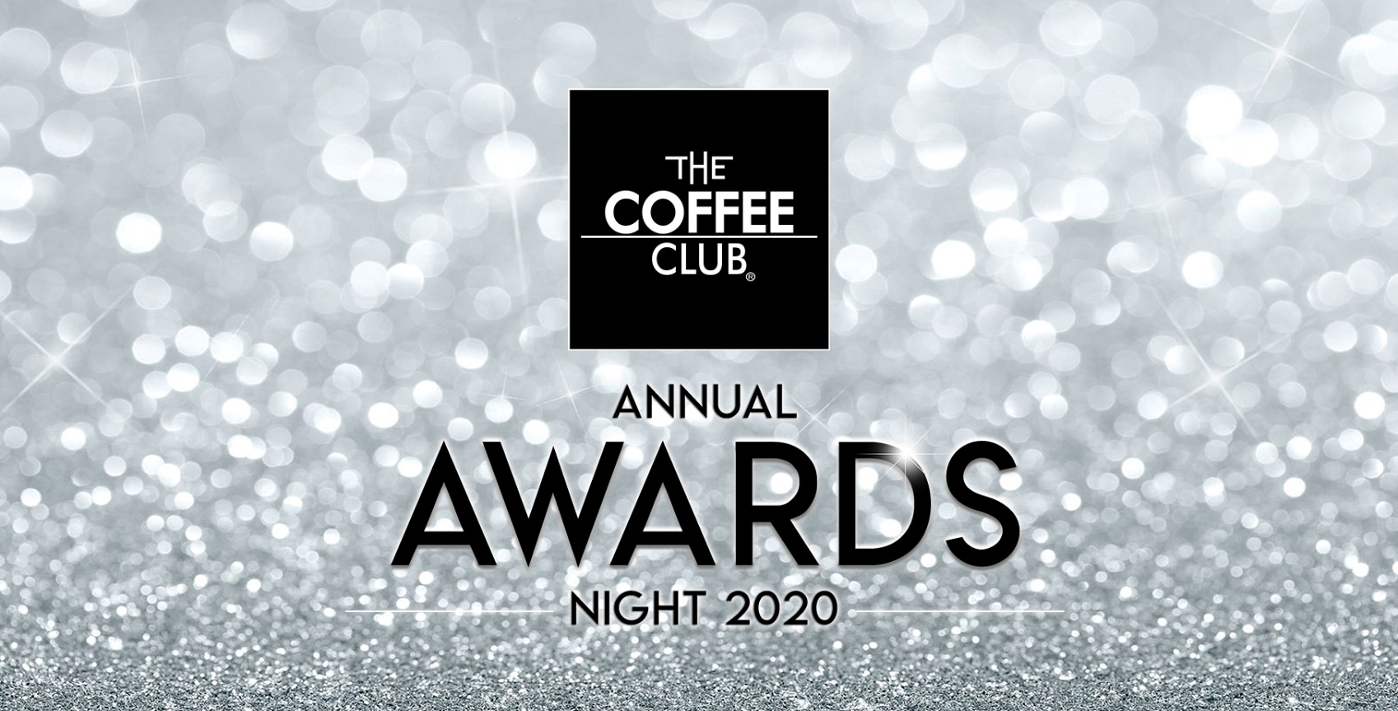

OPERATIONS EXCELLENCE award

The Operations Excellence Award recognises those stores who have the highest level of excellence with regards to overall store operations. This will be largely based on the SVR and BDR scores, branded product compliance, training procedures, equipment maintenance and will also consider feedback you receive in your store, particularly through InMoment.

Nomination DETAILS

Store Name:
Franchisee Name:
Number of team members:
Best contact number:

OPERATIONS EXCELLENCE award SUBMISSION We recommend 1-2 pages

Please answer the following questions with as much detail as you feel necessary. Supporting photos, diagrams, and any other information you believe is important may be included where required.

Questions:

- As a franchisee and leader in your business, how do you communicate information about operations to your team and ensure they are fully aware and supportive of this? For example, operations updates, procedure changes, product changes, etc.
- What sort of training do you provide to your team? This may be formal or informal training.
- How do you ensure your team are engaged and empowered to consistently provide Good Food, Great Service, and Excellent Coffee?
- Please provide an example of an operational improvement you have made to your business in the last 12 months and what this has achieved.
- How do you know that your customers are happy with the service you provide? Give specific examples.

