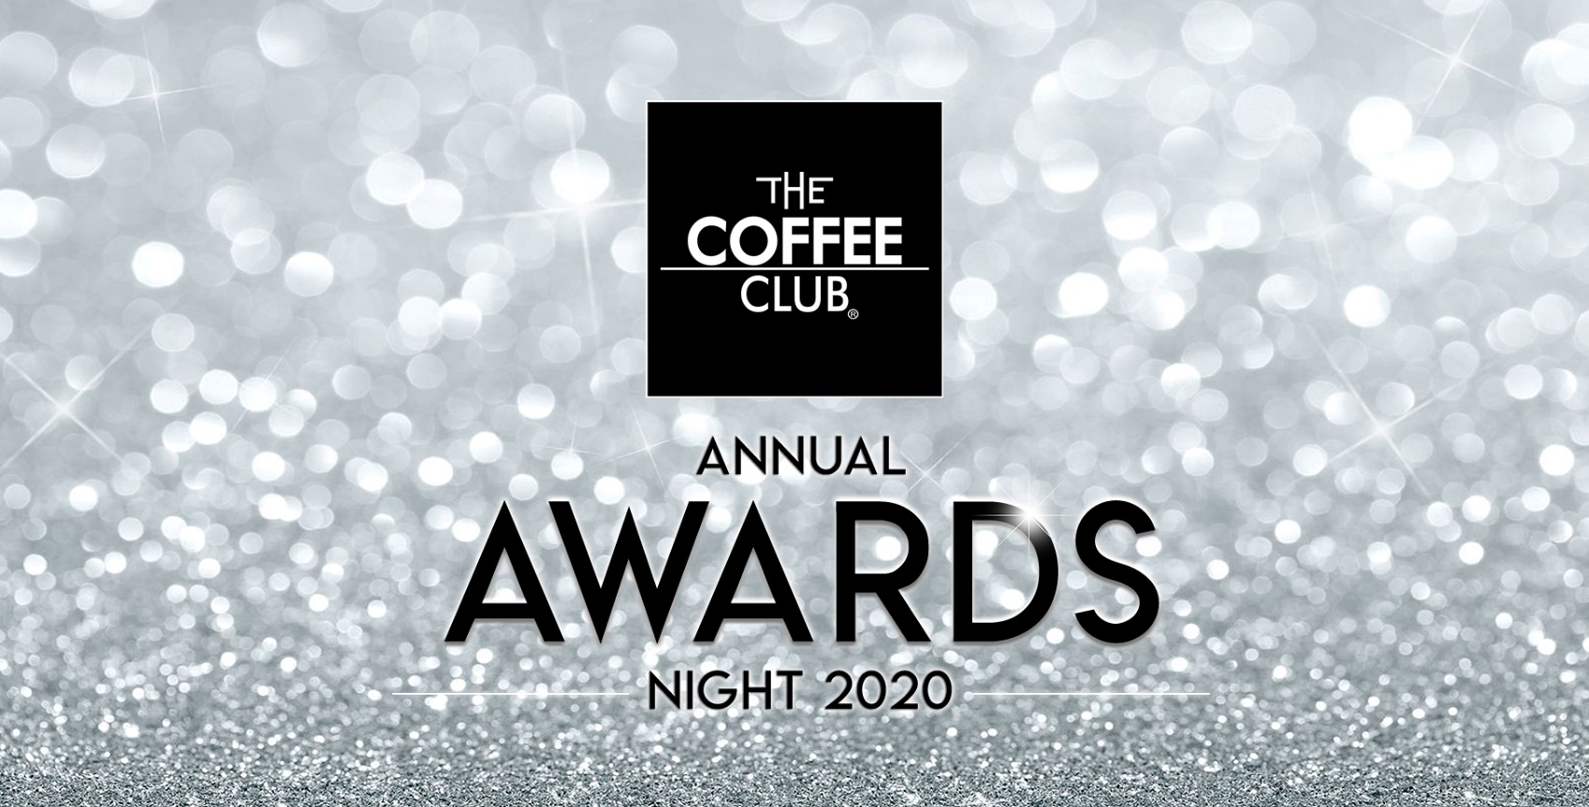

CUSTOMER OBSESSION award

The Customer Obsession Award recognises those who are the best at looking after their customers and ensuring that they provide the best possible customer service to their guests. This award takes into account back of house training resources which are used to ensure all your team are focussed on delivering the best customer experience. It also considers public feedback about your store received via InMoment.

Nomination DETAILS

Store Name:
Franchisee Name:
Number of team members:
Best contact number:

CUSTOMER OBSESSION award SUBMISSION

Please answer the following questions with as much detail as you feel necessary. Supporting photos, diagrams and any other information you believe is important may be included where required.

Questions:

- How do you ensure that you consistently provide a great experience for your customers, so that they want to keep coming back?
- What sort of ‘customer service’ training do you provide to your team?
- Provide any specific examples of things that you do in your store to excel in customer service.
- How do you and your team ensure that your customers feel appreciated and are happy with the service you provide?

